|  |  |
| --- | --- |
| cetlogo ***CHEMICAL ENGINEERING TRANSACTIONS***  ***VOL. xxx, 2025*** | A publication of  aidiclogo_grande |
| The Italian Association  of Chemical Engineering  Online at www.cetjournal.it |
| Guest Editors: Fabrizio Bezzo, Flavio Manenti, Gabriele Pannocchia, Almerinda di Benedetto  Copyright © 2025, AIDIC Servizi S.r.l. **ISBN** 979-12-81206-17-5; **ISSN** 2283-9216 | |

Modeling Biomass Saline Hydrolysis with Aspen Plus: A Study on Agro-Industrial Waste Valorization

Bryan Santos Silva, Reginaldo Guirardello\*

School of Chemical Engineering, University of Campinas, Av. Albert Einstein 500, 13083-852, Campinas-SP, Brazil

guira@feq.unicamp.br

Studies on energy matrices underscore the critical need to transition to sustainable energy sources, emphasizing diversification and the reduction of greenhouse gas emissions. This study uses Aspen Plus software to conduct research focused on the valorization of agro-industrial waste, specifically sugarcane derivatives, through the simulation of an industrial plant using the E-NRTL (Electrolyte Non-Random Two-Liquid) thermodynamic model. This model determines chemical equilibrium and component interactions in the saline hydrolysis of biomass. The proposed approach offers significant advantages: electrolytes facilitate the transformation of the crystalline biomass structure into amorphous forms, enhancing breakdown efficiency and minimizing product degradation during the reaction. Process simulations were conducted using Aspen Plus 8.7 software, based on literature data. Results show that optimal methods and operating conditions depend on the type of salt used. For annual sugarcane bagasse production of 4,000,000 kg, NaCl enables efficient biomass processing at concentrations of up to 20 % by mass, reducing salt consumption and mitigating separation challenges. Conversely, LiBr allows up to 30 % biomass concentration, but requires higher reagent and energy inputs.

* 1. Introduction

The search for new energy matrices has gained increasing global relevance, driven by the need to address environmental challenges and combat climate change. Since studies began in the 1970s, lignocellulosic biomass has emerged as a promising alternative for both energy generation and industrial sugar production. This approach offers an innovative and environmentally friendly solution, with the potential to play a key role in future industrial processes (Araújo et al., 2022).

Biomass, composed of renewable organic materials such as agricultural residues, wood, and energy crops, is a widely available resource that can be converted into valuable products, including bioethanol, bioenergy, and platform chemicals. Conversion processes such as combustion, gasification, saline hydrolysis, and fermentation contribute not only to carbon emission reduction but also to the efficient use of natural resources (de Souza and Nogueira, 2022).

However, the recalcitrant nature of lignocellulosic biomass poses challenges for hydrolysis and fermentation. In this context, saline hydrolysis emerges as a promising approach to facilitate the breakdown of lignocellulosic bonds, particularly in cellulose and hemicellulose. This process involves the addition of salts (or ionic liquids), which act as catalysts in a hydrothermal reaction. The reaction follows a specific order, depending on the nature of the salt and the reaction conditions, and is driven by thermodynamic factors such as temperature and Gibbs free energy. As a result, crystalline cellulose transitions into an amorphous form, enhancing depolymerization and promoting the release of monosaccharides such as glucose and xylose, which are key intermediates for biofuel and biochemical production (Jiang et al., 2018).

This process is advantageous as it operates under milder temperature and pressure conditions compared to conventional hydrolysis, reducing both operational costs and environmental impacts. Additionally, the conversion of lignocellulosic sugars into biofuels (e.g., bioethanol and biodiesel) and other value-added molecules (e.g., furfural, levulinic acid, and 2-methyltetrahydrofuran) makes it a promising alternative for sustainable industrial applications.

This study simulates the saline hydrolysis of biomass using Aspen Plus 8.7, evaluating NaCl and LiBr as catalysts. NaCl was selected for its industrial availability, while LiBr was chosen for its reported efficiency in biomass-to-sugar conversion. The Electrolyte Non-Random Two-Liquid (E-NRTL) model (Bollas et al., 2008) was applied to account for electrolyte interactions. Additionally, a preliminary operational cost analysis was conducted to assess the process's economic feasibility.

* 1. Methodology

Figure 1 illustrates the design of the biorefinery for saline hydrolysis of biomass using two salts (NaCl and LiBr). The biorefinery operations were modeled using Aspen Plus 8.7 (Aspen Tech, Inc., Bedford, USA), with an assumed processing capacity of 4 million tons of sugarcane annually, in an operational year of 200 days, this period is shorter than 365 days due to the off-season, during which there is no sugarcane production, and prolonged storage is not feasible (Leal Silva and Maciel, 2024). The process flowsheet was developed in Aspen Plus using unit operation blocks such as RStoic, Flash2, Heater, and Sep for different steps of the process. The reaction kinetics were not explicitly modeled; instead, stoichiometric conversion was assumed for the hydrolysis reactions, as described in Equations 1 and 2. The use of biomass ranges from 8 % to 48 % of the total biomass (on a dry basis) when using NaCl, with increments of 8 %. Conversely, when using LiBr, the range is 5 % to 50 %, with increments of 5 %. Conversion rates depend on the concentration of biomass and salt at the process input. The unused portion of the biomass is allocated to energy generation and to supply the industrial plant.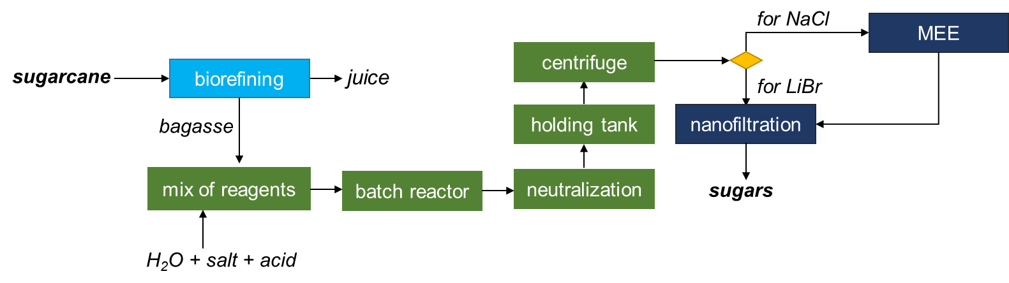

Figure 1: Schematic design of a biorefinery for sugar production from sugarcane bagasse.

Biomass has been added to the software as an insoluble solid compound, a more suitable approach for obtaining sugars from biomass. Eventually, nonconventional solids are used to model solids that are characterized as a function of empirical factors in which the ratio between atoms varies — as is the case with coal. However, cellulose, hemicellulose, and lignin do not need this simplification. Some studies still adopt this simplification to model biomass gasification processes. For this process, the biomass composition is 0.44 % cellulose, 0.33 % hemicellulose, 0.23 % lignin and 0.02 % of ashes (de Morais Rocha et al., 2015).

Another reason for this approach is that Aspen Plus version 14 (the latest) includes a database with these components, and by default, they are conventional solids. This version features cellulose as a glucose polymer, xylan as a xylose polymer, and other polysaccharides, as well as several lignin options (because lignin varies, including H-rich, C-rich, and O-rich types). The thermodynamic model used for the simulations was the ELECNRTL framework, which is suitable for modeling electrolyte solutions and has been validated for systems containing salts and acids. This model was chosen to accurately represent phase equilibria, particularly for the dissolution and interaction of salts in aqueous solutions (Bollas et al. 2008).

For the simulations with NaCl, the conversion rate varies according to the concentration of biomass and salt, ranging from 55 % to 80 % conversion. As the amounts of biomass and salt increase to maintain the same mass ratio across all simulations (and consequently increase the concentration), the amount of water decreases as the concentration of other species increases. In addition, the amount of acid (0.05 % Wt) remains constant in all simulations and acts as a mild catalyst, since higher concentrations of acid could lead to product degradation into unwanted species during the salt hydrolysis process. The biomass concentration at the process input ranges from 5 % to 30 % by mass, increasing by 5 % for each simulation according to the previously mentioned biomass increment.

For the simulations using LiBr, molar ratios of 3.5 water/salt and 69 salt/biomass were applied. In this configuration, the salt (LiBr) approaches a molten salt concentration, achieving a yield of 85 %, while minimizing degradation and the formation of lower sugars such as arabinose and galactose (Deng et al., 2015). The same ratio cannot be used for the simulation with NaCl, as the solubility of LiBr is much higher than that of NaCl, which would result in large amounts of undissolved NaCl in the solution.

The first part of the process is conducted in batch mode with a temperature of 80 ºC (for NaCl) and 120 ºC (for LiBr). The batch mode is employed due to the difficulty of pumping the mixture when the biomass concentration is too high. After mixing the reactants (H2O, salt, and acid), the entire content is transferred to a set of batch reactors where hydrolysis reactions take place, as described by Eq. 1 and Eq. 2 for the formation of glucose and xylose, respectively.

|  |  |
| --- | --- |
| $C_{6}H_{10}O_{5}+H_{2}O→C_{6}H_{12}O_{6}$ | (1) |
| $C_{5}H_{8}O_{4}+H_{2}O→C_{5}H_{10}O_{5}$ | (2) |

After hydrolysis, the acid present (H₂SO₄) in the solution is neutralized with Ca(OH)₂ to form a solid that is insoluble in water and can be easily separated during the solid-liquid separation by centrifugation. Once the acid is neutralized, all the contents are transferred to a storage tank to be processed later in a continuous process.

After separation, the solids are removed from the process, and a washing process with excess water is required, which leads to the recrystallization of type II cellulose.

Up to this point, the entire biorefinery layout has been the same for both salts. However, due to differences in the concentrations of salt, water, and biomass between the two processes, two distinct paths must be followed. When NaCl is used, and the biomass concentration in the process does not exceed 25 % by mass, it is necessary to use multiple-effect evaporators to evaporate large volumes of water at lower energy costs.

A multi-effect evaporator is a configuration of equipment used to concentrate solutions by removing water or solvent through evaporation, while saving energy. It works by harnessing the steam generated in one effect (or stage) as a heat source for the next, thereby reducing energy consumption compared to single-effect evaporation systems.

The multi-effect evaporators were simulated using a combination of Heater, Flash2, HeatX, and Valve models, based on a method described in the literature (Leal Silva et al., 2020) with temperatures (ºC) of MEE: 115.70, 109.00, 100.80, 89.90, 58.90 and pressure (bar): 1.69, 1.31, 0.93, 0.54, 0.16. These evaporators have been integrated into the process to reduce the liquid volume to be treated, which consequently decreases the required size of the separation membrane. Additionally, this configuration was crucial to ensure that the saline solutions remained within the concentration parameters required by the membrane, both before and after the separation process, ensuring that the salts remained diluted. This approach not only optimized membrane usage, preventing overloading, but also increased the overall efficiency of the hydrolysis process by matching operating conditions to the separation system's capacity.

After the first effect, the pressure reduction was adjusted to ensure a minimum temperature difference of 10 °C. For subsequent effects, the pressure reduction was set to maintain a constant heat transfer area relative to the first evaporator. The heat transfer area was calculated using an overall heat transfer coefficient that was estimated through the software. The water outlet from the heat exchangers is directed through pumps to regulate the pressure before being combined into a single water outlet.

With the solutions meeting the concentration standards required by the membrane, the process can proceed to the final phase of component separation by nanofiltration. The separation membrane was modeled based on experimental data (Mallakpour and Azadi, 2022) that relate the use of various types of membranes for salt and sugar separation. The best configuration was identified as the use of NF270 and Desal 5DK membranes. The operation of membrane filtration is illustrated in Figure 2.

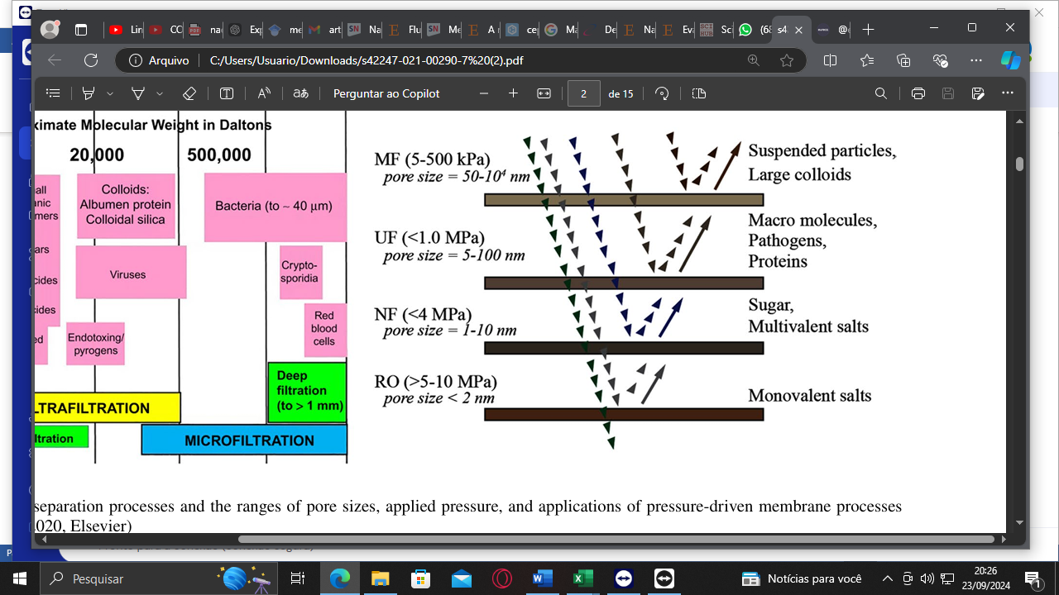

Figure 2: Membrane separation processes and pore size ranges.

For the economic analysis, only the cost of reagents and the sale of the final products were used. Thus, the following considerations were made: sugarcane biomass as the main raw material of the process ($28.0/t), sulfuric acid used as a small catalyst ($79.1/t), water used as the main solvent in the process ($5.5/t), calcium hydroxide ($200.0/t), sodium chloride ($20.0/t), and lithium bromide, whose cost per ton could not be directly found due to its high market value. Instead, it was calculated based on the price per kilogram, estimated at approximately $1200.0/t (Dias et al., 2016; Intratec, 2023; Sabesp, 2024; Businessanalytiq, 2024; Alibaba, 2024). Regarding the products obtained, xylose in a 10 % solution by mass ($72130.00/t) and the glucose solution ($20000.00/t) (Endocommerce, 2024).

* 1. Results and discussion

Figure 3a illustrates the behavior of the products (glucose and xylose), produced and recovered, based on the initial concentration of biomass at the process input when NaCl is used, with the concentration ranging from 5 % to 30 %, and the amount of biomass varying from 8 % to 48 % of the total. Figure 3b shows the same behavior of the products, produced and recovered, through the membrane separation process for the process using LiBr, where here the variant term is the amount of biomass used from the total biomass available.

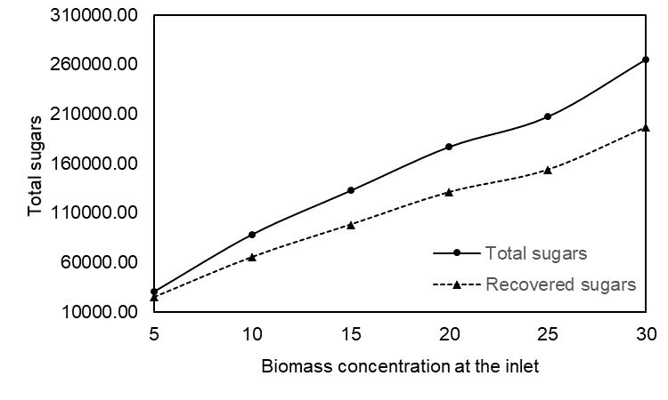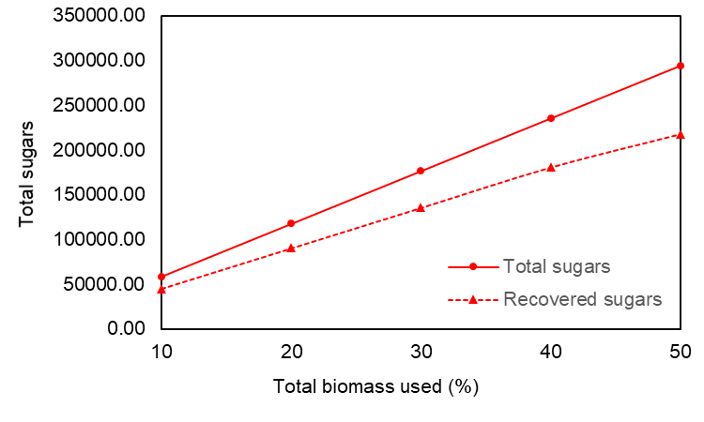

a) b)

Figure 3: a) Amount (kg/h) of sugars produced and recovered by mass concentration (percentage) of biomass at the process input. b) Amount (kg) of sugars produced and recovered by the amount of biomass (%) at the process input relative to the total biomass available.

It is possible to observe that, as the concentration of biomass at the entrance increases, there is a progressive growth in both total and recovered sugars. However, the recovery of sugars does not exactly follow the increase in total sugars, **indicating** a divergence trend between the two curves.

This difference suggests that, despite the increase in the amount of biomass processed, not all total sugars present in the system are completely recovered, which may be indicative of limitations in the separation or recovery process. At the beginning of the graph, up to a concentration of 10 %, the amount of total and recovered sugars **exhibits** a similar behavior. However, from this point on, the deviation between the curves becomes more evident, especially **at** concentrations of 25 % and 30 %, where the total sugars increase significantly, but the recovery is proportionally smaller.

This can be explained by factors such as the efficiency of the membranes or other aspects of the separation process, such as the large amount of salts present in these concentrations. As the amount of biomass increases, the recovery process can be hampered by limitations in extraction capacity or by the saturation of the salts present. **Figure 4 presents the comparison between the products.**

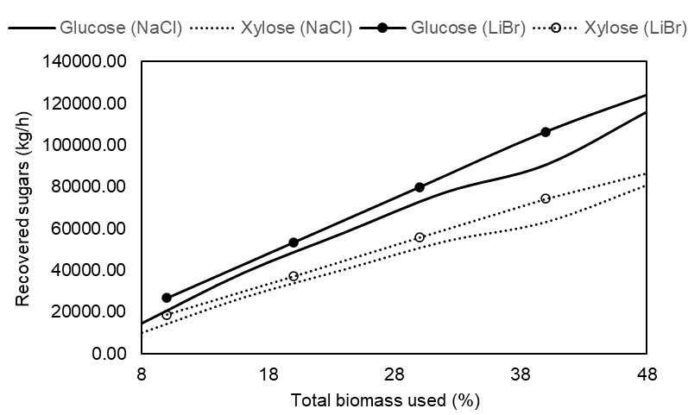

Figure 4: Comparison of xylose and glucose production by the studied salts.

Figure 4 shows that the use of LiBr results in higher yields for both glucose and xylose compared to NaCl. This behavior can be explained by the more favorable conditions provided by LiBr, such as higher temperature and concentration, which promote a more efficient hydrolysis. The production of glucose, in particular, **shows** more marked differences between the two salts, **focusing solely on quantities, which indicates** that LiBr is especially efficient in the breakdown of cellulose, a direct precursor of glucose.

In addition, regardless of the salt used, it is observed that glucose production is consistently higher than that of xylose. This difference is **easily attributed to** the composition of the biomass, which generally contains a higher proportion of cellulose (the basis for glucose) **compared to** hemicellulose (the precursor of xylose). **During the product separation step,** a nanofiltration membrane is used. Figure 5 shows a comparison between the membrane sizes required for the process.

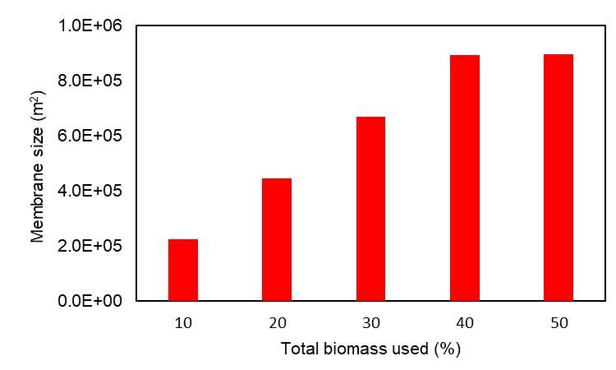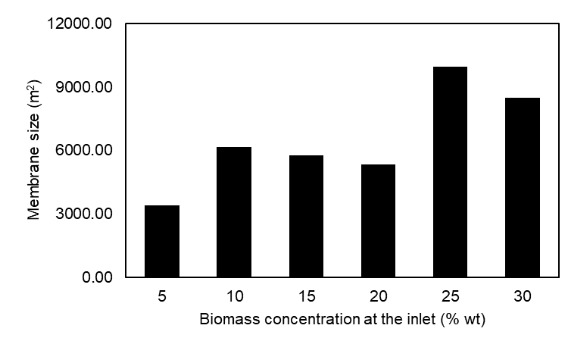

a) b) b)

Figure 5: a) membrane size for NaCl simulation. b) membrane size for LiBr simulation.

The membrane size was calculated based on the mass flow it can handle without compromising filtration. Anomalous and nonlinear behavior was observed due to variations in each process step. The smallest membrane was recorded at 5% biomass, justified by the use of five evaporative effects, which remove more water and reduce membrane size and salt demand.

Between 10% and 20% biomass, membrane size decreased linearly, as higher biomass means less initial water and, consequently, less water generated. At 25% and 30%, membrane size increased significantly due to the absence of evaporators and the need for dilution before filtration to avoid salt-related issues. For LiBr, membrane size increased with biomass due to higher water content, influenced by the simulated proportions.

In the economic analysis for NaCl, the increase in the quantities produced results in increasing total costs – due to the increase in the amount of reagents used, but the revenue also increases significantly. For example, at 30% concentration, the production revenue reaches approximately U$8,151,084.10, evidencing the viability of production in large quantities.

However, each simulation has its peculiarity, such as the simulation in which the biomass is more diluted (5 %), where there is a large amount of water compared to the other concentrations, in addition to the need to use one more effect in the evaporators, which could make the process more expensive. On the other hand, this is the simulation in which there is more recovery of sugars. For the biomass concentration of 30 % and 25 %, although they do not use multiple-effect evaporators, the concentration of solids in these simulations is high, which leaves the mixture non-pumpable or requiring an extremely powerful pump, increasing energy consumption and equipment wear. Thus, simulations using average biomass concentrations become more attractive, as they do not require excessive water and are easier to pump.

For the LiBr simulations, the process is only viable if reagent reuse is implemented due to the high cost of LiBr. If 75 % of the reagent is reused monthly, the first four simulations show profitability. However, the simulation using 50 % of the total biomass still results in losses, highlighting the necessity of reagent reuse.

Finally, although the goal of this work is to obtain the sugars of interest, they can be converted into other higher-value-added and industrially significant products, such as ethanol through fermentation, furfural, MTHF, HMF, formic acid, and other products.

* 1. Conclusions

A study of the valorization of sugarcane biomass residues was carried out considering a saline hydrolysis process. Although higher concentrations generate greater quantities of products, some counterpoints are important, such as the **increased costs**, **the difficulty in pumping the solution due to high biomass concentrations**, and **the reduced efficiency of product separation as the biomass volume increases**. On the other hand, lower concentrations of biomass generate higher conversions and higher recovery rates; however, the large volume of water required for low concentrations **can result in additional operating costs associated with multiple-effect evaporators**. The use of intermediate biomass concentrations (20 % by mass) becomes a viable alternative for this reaction (for NaCl), while **lower amounts of biomass (30 % of the total available) are recommended when using LiBr** to avoid the main disadvantages of the process. Additionally, **higher temperatures (greater than 120 °C)** can result in the degradation of sugars into other products; therefore, it is necessary to maintain temperatures below **this threshold**.

Acknowledgments

The authors acknowledge the support from Coordenação de Aperfeiçoamento de Pessoal de Nível Superior - Brasil (CAPES) – grant n. 88887.826403/2023-00.

References

Araujo R.O., Ribeiro F.C.P., Santos V.O., Lima V.M.R., Santos J.L., Vilaça J.E.S., Chaar J.S., Falcão N.P.S., Pohlit A.M., de Souza L.K.C., 2022, Renewable Energy from Biomass: an Overview of the Amazon Region. Bioenerg. Res. 15, 834–849.

Avantor. Lithium bromide, anhydrous 99%, pure. Available at: <https://www.alibaba.com/product-detail/99-Lithium-Bromide-CAS-7550-35\_1600322338746.html?spm=a2700.galleryofferlist.normal\_offer.d\_title.222b13a0CvofdI> accessed 23.10.2024.

Bollas G.M., Chen Chau-Chyun, Barton P.I., 2008, Refined electrolyte‐NRTL model: Activity coefficient expressions for application to multi‐electrolyte systems. AIChE Journal, 54, 1608–1624.

Businesanalytiq. Sodium Chloride and Calcium Hydroxide price index. Available at: <businessanalytiq.com/procurementanalytics/index/sodium-chloride-price-index/> accessed 23.10.2024

Rocha G.J.M., Nascimento V.M., Gonçalves A.R., Nunes Silva V.F., Martin C., 2015, Influence of mixed sugarcane bagasse samples evaluated by elemental and physical–chemical composition. Industrial Crops and Products, 64, 52–58.

Morais E.R., Junqueira T.L., Sampaio I.L.M., Dias M.O.S., Rezende M.C.A.F., de Jesus C.D.F., Klein B.C., Gómez E.O., Mantelatto P.E., Maciel Filho R., Bonomi A., 2016, Biorefinery Alternatives, Springer, Cham, 53–132, 10.1007/978-3-319-26045-7\_4

de Souza T.A., Nogueira F.J.F., 2022, Alternativas de energia no Brasil: biomassa, eólica e solar. Caderno de Estudos em Engenharia Elétrica, v. 4, n. 1.

Deng W., Kennedy J.R., Tsilomelekis G., Zheng W., Nikolakis V., 2015, Cellulose hydrolysis in acidified LiBr molten salt hydrate media. Industrial & Engineering Chemistry Research, 54, 5226–5236.

Dias M.O.S., Junqueira T.L., Sampaio I.L.M., Chagas M.F., Watanabe M.D.B., Morais E.R., Gouveia V.L.R., Klein B.C., Rezende M.C.A.F., Cardoso T.F., Souza A., Jesus C.D.F., Pereira L.G., Rivera E.C., Maciel Filho R., Bonomi A., 2016. Use of the VSB to Assess Biorefinery Strategies, Springer, Cham, 189–256.

Endocomerce, xylose solution. Available at: <endocommerce.com.br/p/solucao-de-xilose-xil-o-test>. accessed 23.10.2024

Intratec. Sulfuric Acid Price | Current and Historical. Available at: <www.intratec.us/chemical-markets/sulfuric-acid-price>. accessed 23.10.2024.

Jiang Z., Fan J., Budarin V.L., Macquarrie D.J., Gao Y., Li T., Hu C., Clark J.H., 2018, Mechanistic understanding of salt-assisted autocatalytic hydrolysis of cellulose. Sustainable Energy & Fuels, 2, 936–940.

Klein B.C., Leal Silva J.F., Junqueira T.L., Rabelo S.C., Arruda P.V., Ienczak J.L., Mantelatto P.E., Pradella J.G.C., Vaz Junior S., Bonomi A., 2017, Process development and techno‐economic analysis of bio‐based succinic acid derived from pentoses integrated to a sugarcane biorefinery. Biofuels, Bioproducts and Biorefining, 11, 1051–1064.

Leal Silva J.F., Maciel Filho R., 2024, Techno-economic Analysis and Life Cycle Assessment of Renewable Acetaldehyde from Sugarcane Ethanol. Chemical Engineering Transactions, 109, 175–180.

Leal Silva J.F., Maciel Filho R., Wolf Maciel M.R., 2020. Process design and technoeconomic assessment of the extraction of levulinic acid from biomass hydrolysate using n-butyl acetate, hexane, and 2-methyltetrahydrofuran. Ind. Eng. Chem. Res. 59, 11031–11041.

Mallakpour S., Azadi E., 2022, Nanofiltration membranes for food and pharmaceutical industries. Emergent materials, 5, 1329–1343.

SABESP.Tarifas: Available at: <site.sabesp.com.br/site/interna/Default.aspx?secaoId=183>. Accessed at: 23 out. 2024.